Identification of the Flow Dependent Ecosystems and their Services
in the Indian Sundarbans

Tuhin Bhadra*ª, Subrata Mitra ª, Sugata Hazra^{b}

ABSTRACT

The Indian Sundarbans, located in the south western end of ganges delta, is a part of deltaic West Bengal. It hosts the world’s largest mangrove ecosystem and supports almost 5 million population. The region is characterized by its mangrove forest, mudflats, estuaries, creeks, floodplain, freshwater wetlands and these land covers are modified from time to time by river action. Freshwater is a scarce resource in Sundarbans, though it is crisscrossed by numeurous rivers and creeks. The river water and shallow groundwater are saline in the Sundarbans. Scarcity of freshwater during dry seasons, high salinity of surface water and soil, siltation and drainage congestion are major constrains of livelihood security in this area. The people of the region depend on the ecosystem services of Sundarbans which are directly linked with upstream freshwater flow, rain and groundwater. The present study is therefore designed to identify the flow dependent ecosystem services in the region for their sustainable management.

- Introduction
The Millennium Ecosystem Assessment (MEA) report 2005 defines Ecosystem services as benefits people obtain from ecosystems. The ecosystem services are classified as (i) Provisioning services, i.e. products obtained from ecosystems, (ii) Regulating services, benefits obtained from the regulation of ecosystem, (iii) Cultural services, i.e. non- material benefits that people obtain through spiritual enrichment, recreation etc. and (iv) Supporting services i.e. necessary for the production of all other ecosystem services. Food, fiber, fuel are provisioning services, water regulation, pollution control are regulating services, spiritual enrichment, cognitive development, recreation are cultural services and soil formation and retention, nutrient cycling, primary production, water cycling are

ª Department of Geography, Adamas University, Kolkata 126
^{b}School of Oceanographic Studies, Jadavpur University, Kolkata 32
*Corresponding author email id: tuhinbhadra.au@gmail.com

supporting services. Ecosystem functions result in the generation of such benefits. These benefits are very significant to the wellbeing of human beings. The present study is designed to identify the ecosystem services of the Indian part of the world’s largest mangrove ecosystem, Sundarbans, which is located at the south western end of the Ganges-Brahmaputra-Meghna delta was formed during 11000-3000cal year BP [1] by the interaction between upstream fresh water from the river Ganges and saline sea water of the Bay of Bengal.
The Sundarban Biosphere Reserve (SBR) of India extends from 21°33'32.62" N to 22°38'15.66"N and 88°2'27.42"E to 89°5'46.06"E, is a part of deltaic West Bengal and includs the districts of North 24 Parganas and South 24 Parganas. The area is bounded by River Hoogly in the west, Ichamati- Raimangal- Harinbhanga in the east, Dampier-Hodges line in the north and the Bay of Bengal in the south. Total area of SBR is 9630 sq km. comprising the block region of 5367 sq km. and reserve forest area of 4263 sq km. The forest area is

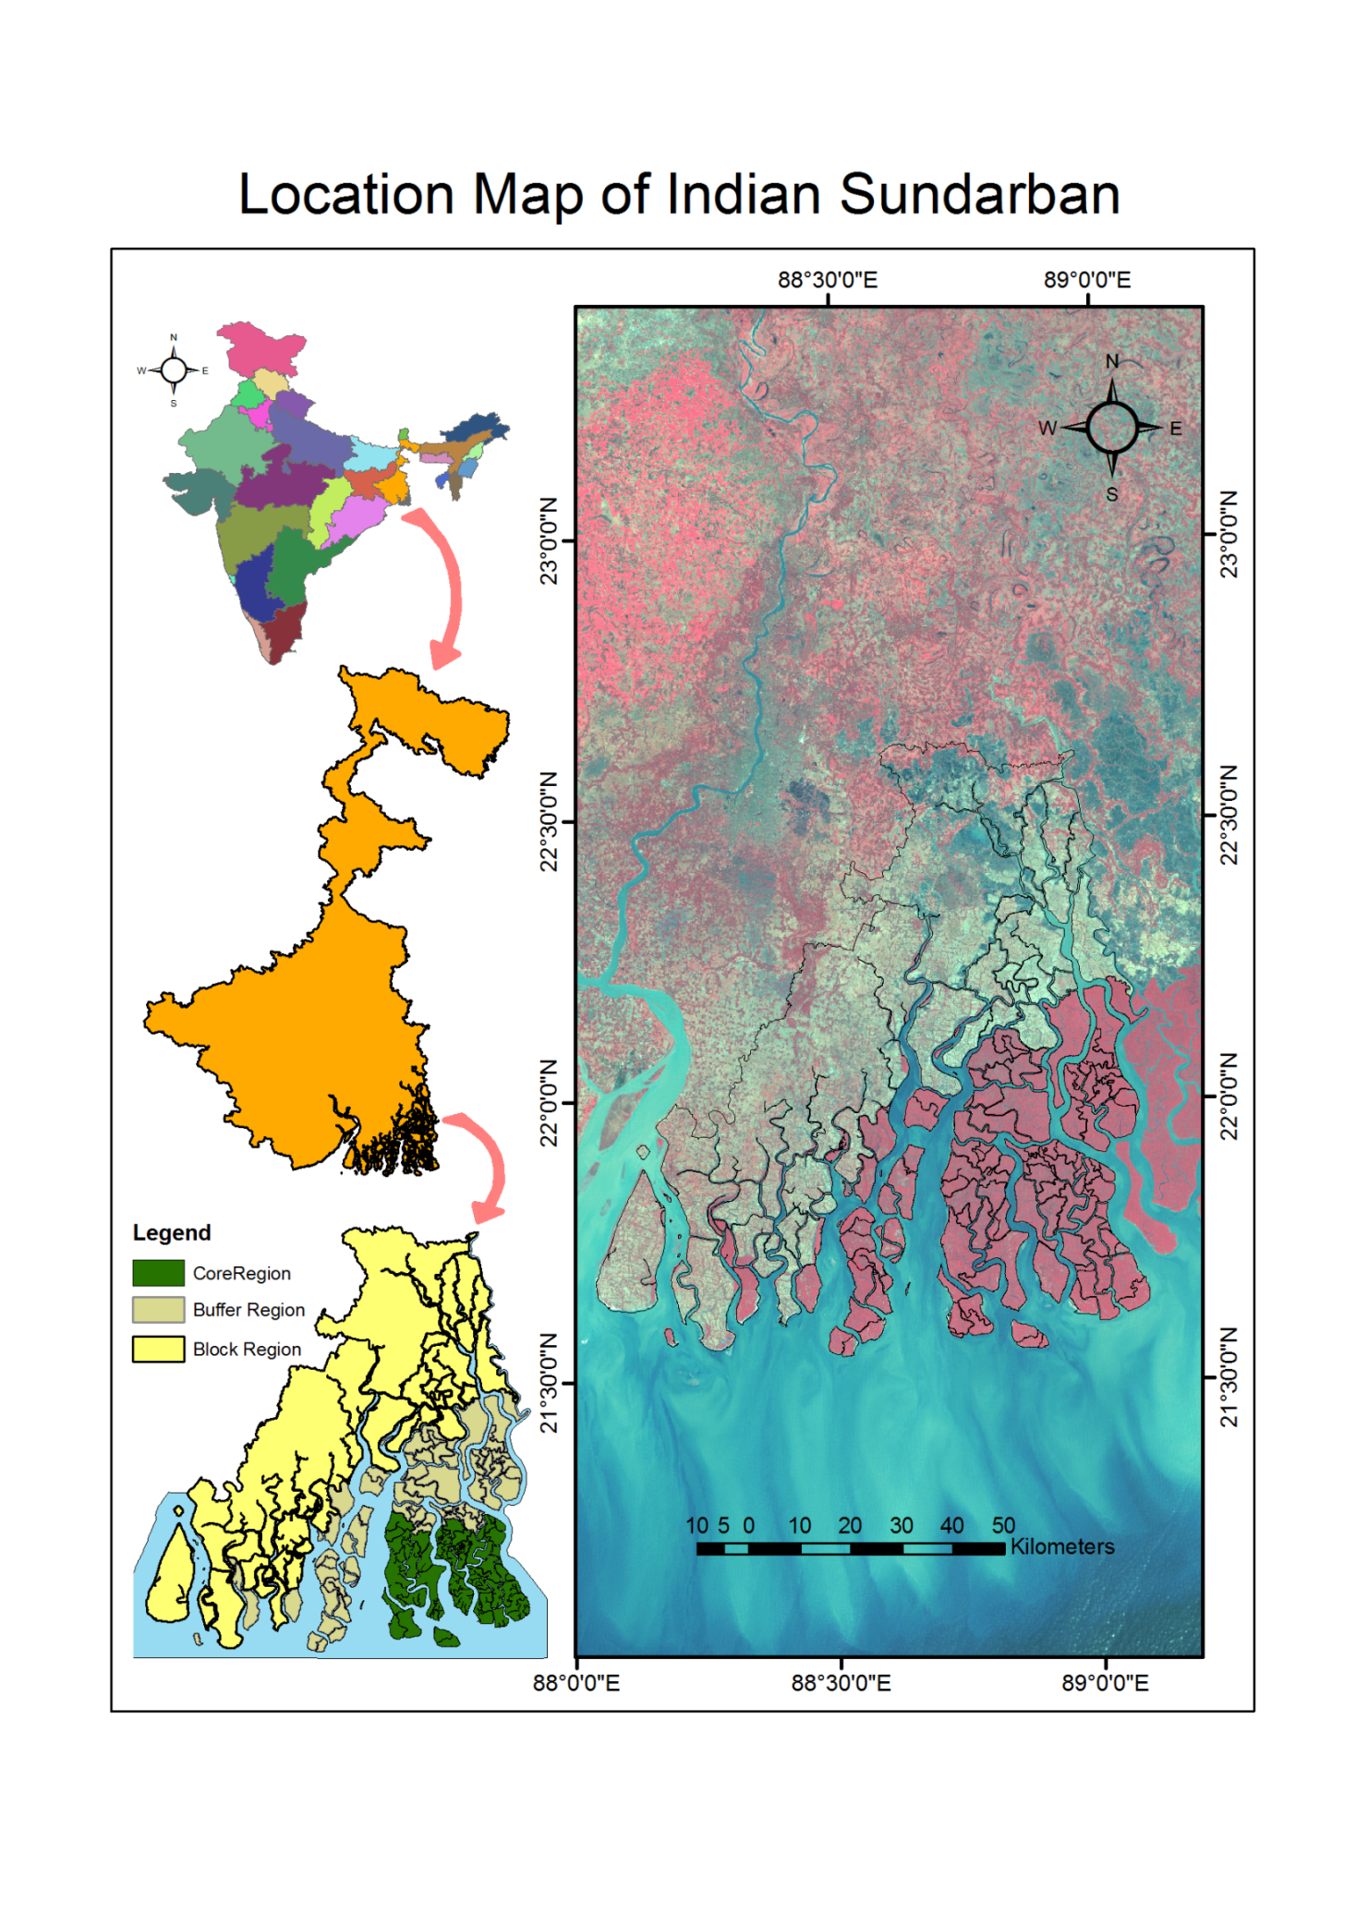
further subdivided into two parts, a Core area and a buffer area. There are 19 blocks in Indian Sundarban, out of which 13 fall under South 24 Parganas and 6 falls under North 24 Parganas district of West Bengal India. The SBR hosts the world’s largest mangrove forest and supports over 4.5 million population.
Figure 1: Location of the Study Area
People living in the forest cleared inhabited area of the SBR depend on its ecosystem services which are directly linked with freshwater availability from rivers, rain, and groundwater. The SBR is characterized by the mangrove forest, mudflats, estuaries, creeks, floodplain, freshwater wetlands and these land covers are modified from time to time by river action. The prevailing freshwater flow into the SBR depends on the hydrological conditions of its rivers. The rivers of the SBR have lost their links with their parent rivers and get limited amount of monsoonal runoff from the upstream basins [2,3,4]. The river water are mostly saline in estuarine and saline water tidal region and fresh in the freshwater tidal region. The groundwater is

also saline except for a few meters thick confined aquifers which occur at variable depth ranging from 160 to 400 m [5]. Saline water intrusion into the shallow aquifers makes the shallow groundwater brackish. The Ecosystem and biodiversity of the SBR depend on the hydrological regimes of the estuarine rivers. Variation in quantity and quality of flow can alter the functioning of the ecosystems, which in turn produces changes in services of these ecosystems. In this perspective, the main objectives of this study are to identify the major flow dependent ecosystems and their services in Indian Sundarbans based on existing literature and experts openion.
- Result & Discussion
Ecosystems and their biodiversity of the Sundarbans depend on the hydrological regimes such as freshwater inflow from upstream, rainfall, tidal flows, salinity with topography and substrate. There are four major flow dependent ecosystems in the Sundarbans. These are the mangrove ecosystem, the riverine ecosystem which further may be subdivided into freshwater and saline water tidal blocks, the estuarine ecosystem and the floodplain-freshwater wetland ecosystem (Fig. 2). Each of these ecosystems performs a variety of ecosystem services (Table 1.1) like drainage, navigation, sediment flushing, shoreline stabilization, prevention of salt intrusion, storm protection, recycling of organic nutrients, carbon sequestration, food and other resources supply etc. Provisioning of nursing-breeding-feeding ground for aquatic animals is a major service of these ecosystems. The ecosystem services increase and decrease depending on flow availability from upstream. The function of these ecosystems and their interconnections is related with the freshwater flow from upstream, tidal flow from the Bay of Bengal and their intermixing pattern. The biodiversity of Sundarbans includes numerous floral and faunal species [6] (Table 1.2). The habitat of all the species (Table 1.2) in the Sundarbans depends on freshwater inflow, tidal range, depth, velocity, cross-section and salinity of the rivers.
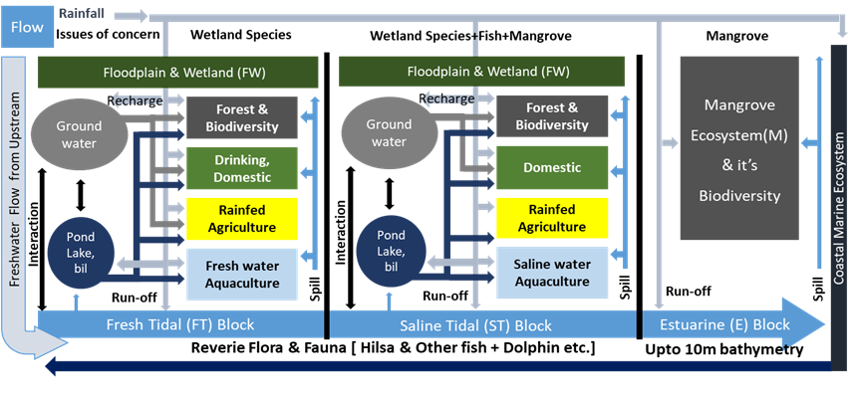
Figure 2: Flow network and flow dependent Ecosystem Services of the Study Area (After Bhadra, 2013)

The breeding-nursing ground of fish and their migration path are highly dependent on the above flow related components. For example, migration of Hilsa commences only with the monsoon rain and increased freshwater flow in the estuary while the famous Sundari tree fails to cope with the lack of fresh water in the estuarine islands. The Sundarbans mangrove vegetation consists of a group of plants of special adaptation that thrives in a wide gradient of salinity. About 100 species of mangrove plants representing 34 families and 57 genera are present in Indian Sundarbans [6] out of which 25 are true mangrove species, 30 are mangrove associates and 37 are black mangroves. The Indian Sundarban is dominated by the Rhizophoraceae and Avicenniaceae whereas the Bangladesh Sundarbans is dominated by the Heritiera and Excoecaria [6]. The Heritiera (Sundari) is considered an endangered species in Indian Sundarbans as it is rapidly disappearing due to less freshwater inflow from upstream and high salinity condition [6,7]. The Nypa fruticans, Phoenix paludosa, Xylocarpus mekongensis are the other rare and endangered flora in the Indian Sundarbans.

Table 1: Services of four major ecosystems in the study area

Type of Services | Ecosystem Services | Ecosystems
Regulating services | Groundwater replenishment | FT/FW
Regulating services | Drainage, Flushing | R/E
 | Shoreline stabilization | E/M
 | Sustaining the livelihood | FW/R/E/M
 | Prevention of salt intrusion | R/E
 | Regulating Hydrological cycle | FW/R/E/M
 | Pollution control | FW/R/E/M
 | Influence on climate | FW/R/E/M
 | Dilution of wastewater | FW/R/E
 | Storm and Erosion protection | M
 | Carbon sequestration | M/FW
Provisioning services | Food (fish) | FW/R/E
Provisioning services | Drinking water,  Irrigation | FW/FT
 | Domestic water uses | FW/R/E
Supporting services | Soil formation and retention | FW/R/E/M
Supporting services | Navigation | R/E
 | Wild resources | FW/R/E/M
 | Provision of habitat | FW/R/E/M
 | Support to coastal ecosystem | M /E
 | Nursery/breeding/feeding grounds | FW/R/E/M
 | Biodiversity and genetic resources | FW/R/E/M
 | Organic matter nutrients storage | FW/R/E/M
 | Recycling of organic matter | FW/R/E
 | Recycling of pollutants | FW/R/E/M
 | Export of organic matter | R/E/M
Cultural services | Spiritual and religious value | R/E /FW
Cultural services | Cultural heritage value | R/E/M/FW
 | Recreation and ecotourism | FW/R/E/M
R = Riverine (Tidal and non-tidal), FT=Freshwater Tidal, ST=Saline water Tidal, E=Estuarine, M=Mangrove, FW= Floodplain Wetland.

World’s only freshwater-brackish water mangrove forest, has a rich faunal diversity which includes the terrestrial, freshwater, marine and intertidal creatures. The Royal Bengal Tigers (Panthera tigris tigris), Estuarine Crocodile (Crocodylus porosus), Gangetic Dolphin (Platanista gangetica), Olive Ridley Turtles (Lepidochelys olivacea), River Terrapins (Batagur baska) and Horseshoe Crab (Carcinocorpus rotandicuda) are major endangered fauna of the Indian Sundarbans.
The Sundarbans supports a rich estuarine-marine fish biodiversity. Rivers, estuaries and regularly flooded lands are the main habitats for fish in the Sundarbans. Species like Bhetki (Lates calcarifer), Hilsa (Tenualosa ilisha), Bagda (Penaeus monodon) and mud crabs (Scylla serrata) are common species in this region [8, 9,

[10]. Marine fishes spawn in the areas where salinity is less than 26 PSU where they stay for a few months and then return back to the sea with the onset of monsoon (ibid). The economy of the Sundarbans is directly linked with these fish resources.
The community development (CD) block region of the SBR is inhabited by a 4.43 million [11] strong population. According to Hazra (2003) [12] the population of Indian Sundarbans in the year 2020 will be 5.2 million and in 2050 it will reach 8.8 million (calculated on the basis of 1991- 2001 growth rate), which will exceed the carrying capacity of this vulnerable ecosystem. The people of the SBR, mainly those living in areas adjacent to the reserve forest are dependent on the natural resources of the forest to supplement their livelihood. A large number of people are directly or indirectly engaged in resource utilization (for example, extraction of fish, honey, wax, fuel wood and leaves of trees etc.) of the forest area to which they are permitted access. As the productivity of the forest depends on the quality and quantity of flow, so a minimum flow is required to sustain the forest as well as the forest-dependent livelihoods. Agriculture (65%) and fishing (17%) are major livelihoods of the people of Sundarbans, which too depend directly or indirectly on the health of the ecosystem and flow. The saline river water and groundwater are not used for agricultural purpose, so agriculture mainly depends on irrigation from surface water bodies and rainfall. With small land holdings and limited irrigation facilities, the intensive subsistence agriculture is only practised in the SBR. The rich ecosystem of the forest supports a wide variety of fin and shellfish species. As habitat criteria and migration path are determined by the quality and quantity of water, the fishing activity directly depends on flow availability.
- Conclusion
The study reveals that the ecosystem services in Sundarbans are mostly dependent on freshwater availability from the upstream region. Nvigation, recreation, Food (fish), Storm and Erosion protection, Carbon sequestration, Provision of habitat, Recycling of pollutants are some of the major services of the ecosystem of Sundarbans. The services might be improved by improving freshwater vailabiliy in the region. River restoration and reconnection is the only option to improve freshwater availibility and water dependent ecosystem servevices in Sundarbans. The study will help the future researchres to assess the value of the esosystem services in Sundarbans.

Acknowledgement
The first author would like to acknowledge the fellowship support from University Grants Commission (UGC), India which enabled him to accomplish the study. The authors are indebted to the IUCN, India for providing the financial support to conduct the field investigations. The authors would like to express their gratitude to Mr. Subhas Acharya (Ex. Officer, Sundarban Development Board, Government of West Bengal) for proving useful information relevant to the study.

References
- Goodbred Jr., S.L. & Kuehl, S.A. (2000). The significance of large sediment supply, active tectonism and eustasy on margin sequence development: Late Quaternary stratigraphy and evolution of the Ganges-Brahmaputra Delta. Sediment Geol 133(3), 227-248.
- Gole, C.V. & Vaidyaraman, P.P. (1966). Salinity distribution and effect of freshwater flows in the Hooghly River. In: Proceedings of 10th Conference on Coastal Engineering, Tokyo, Japan, September 1966 (American Society of Civil Engineers, New York) pp 1412–1434
- Bhadra, T., Mukhopadhyay, A. and Hazra, S. (2017). Identification of River Discontinuity Using Geo-Informatics to Improve Freshwater Flow and Ecosystem Services in Indian Sundarban Delta, In Hazra, S. et al (Eds.), Environment and Earth Observation, Springer Remote Sensing/Photogrammetry, Springer, Cham, pp.137-152.
- Hazra, S., Bhadra, T., & Ray, S. P. (2019). Sustainable Water Resource Management in the Sundarban Biosphere Reserve, India. In Ground Water Development-Issues and Sustainable Solutions (pp. 147-157). Springer, Singapore.
- Bhadra, T., Hazra, S., Sinha Ray, S. P., & Barman, B. C. (2020). Assessing the groundwater quality of the coastal aquifers of a vulnerable delta: A case study of the Sundarban Biosphere Reserve, India. Groundwater for Sustainable Development, 11, 100438.
- Gopal, B. & Chauhan, M. (2006). Biodiversity and its conservation in the Sundarbans Mangrove Ecosystem. Aquat Sci. 68, 338–354.
- Barik, J., & Chowdhury, S. (2014). True mangrove species of Sundarbans delta, West Bengal, eastern India. Check list, 10(2), 329-334.
- Bhadra, T. (2013). A Study on Fresh-Water Availability in Indian Sundarbans Delta. Unpublished M.Phil. Dissertation, School of Oceanographic Studies, Jadavpur University, Kolkata
- Hazra, S., Khan, M. F. A., Kansal, M. L., Barman, B. C., Bhadra, T., Ghosh, S., Saniruzzaman, S. and Chandniha, S. K. (2015a). Methodology for Assessment of Environmental Flows for the Sundarbans Ecosystem (A pilot study). IUCN-India, p.200. (Unpublished Report)
- Hazra, S., Bhadra, T., Ghosh, S. and Barman, B. C. (2015b). Assessing environmental flows for Indian Sundarban: A suggested approach’, River Behaviour and Control – Journal of the River Research Institute, 35, 65-74
- Govt. of India. (2011a). Population Census 2011, Primary Census Abstract, North and South 24 Parganas District, West Bengal. Office of the Registrar General Census Commissioner.
- Hazra, S. (2003). Vulnerability Assessment in a Climate Change Scenario: A Pilot Study on Ecologically Sensitive Sundarbans Island System, West Bengal. Unpublished Report, Submitted to MoEF.

